Dashboard 1: Social Media Usage Overview
Objective:
Understand platform preferences and time spent patterns among students.
Visuals:
- Donut Chart – Distribution of platforms (Instagram, WhatsApp, YouTube, etc.)
- Bar Chart – Average hours spent per platform
- Bar Chart – Usage Category Comparison
- KPI Cards – Avg. hours/day, % heavy users (>4 hrs)
Filter Pane: Age | Gender | Platform
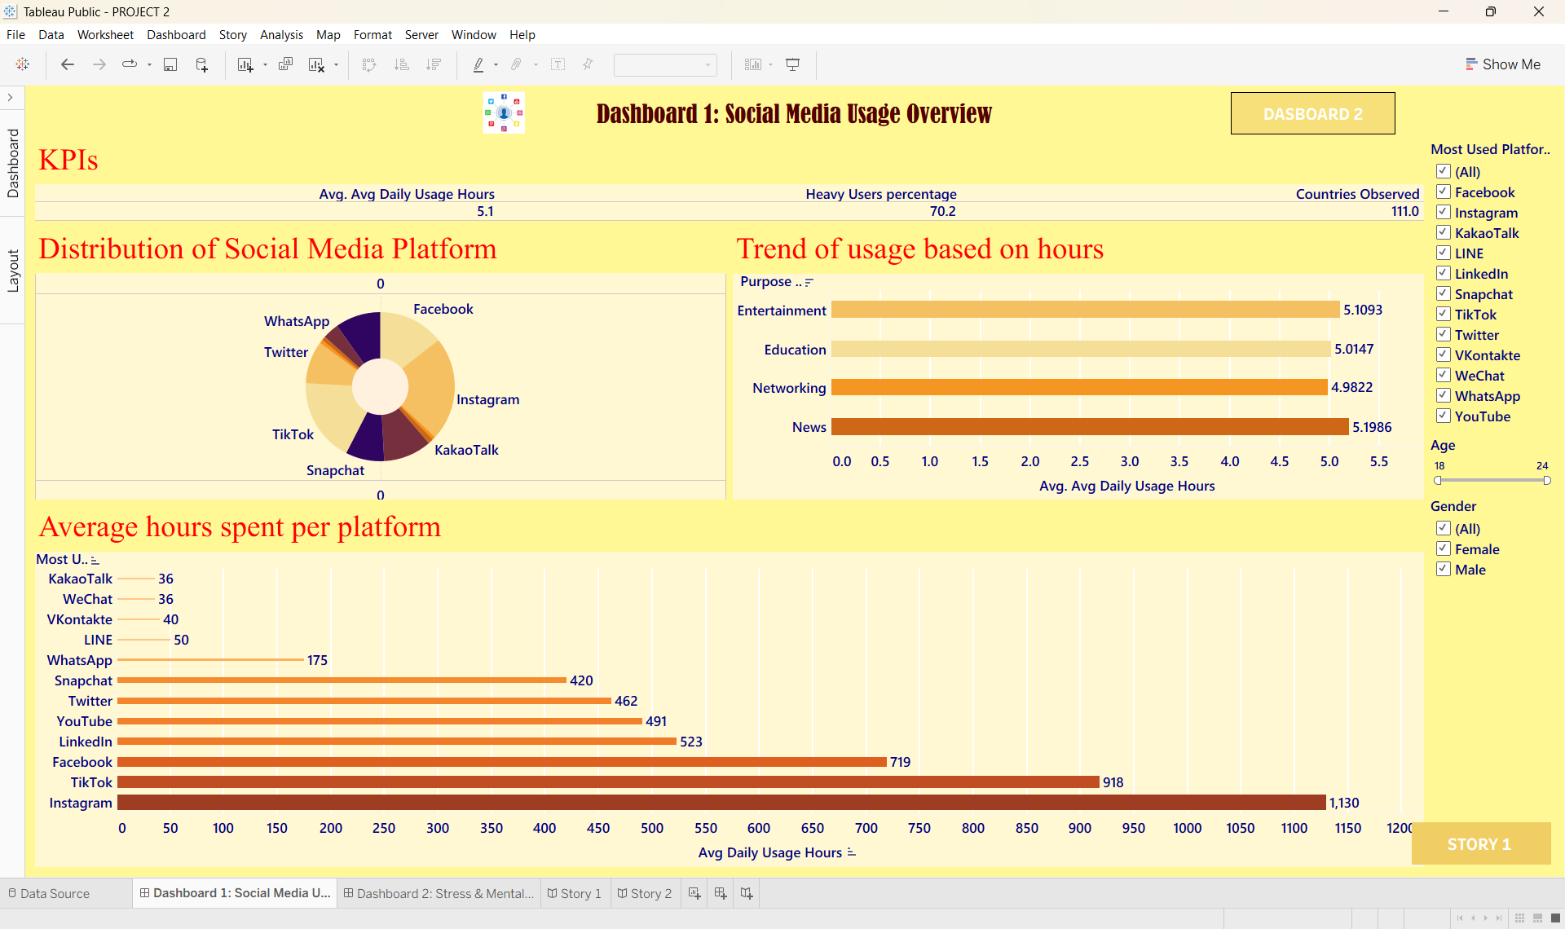
DASHBOARD-

STORY-
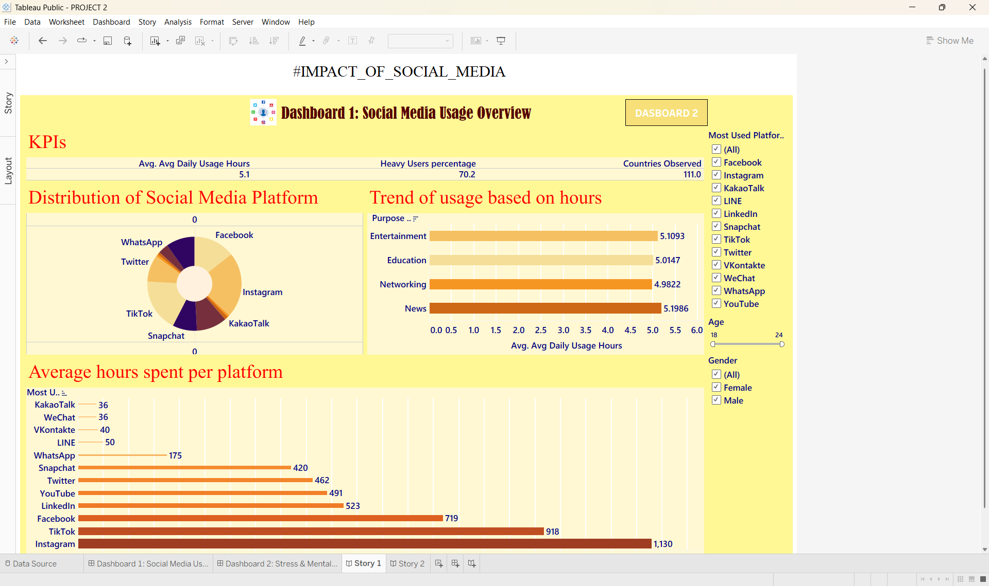

Dashboard 2: Stress & Mental Health Analysis
Objective:
Explore how social media usage correlates with stress levels.
Visuals:
- Scatter Plot – Study Hours vs. Mental Health Score among different academic levels
- Heat Map – Stress levels by Age × Gender
- Bar Chart – Avg. stress score by platform
- KPI Cards – % students reporting high stress, Avg. stress score
Filter Pane: Platform | Age Group | Gender

DASHBORD
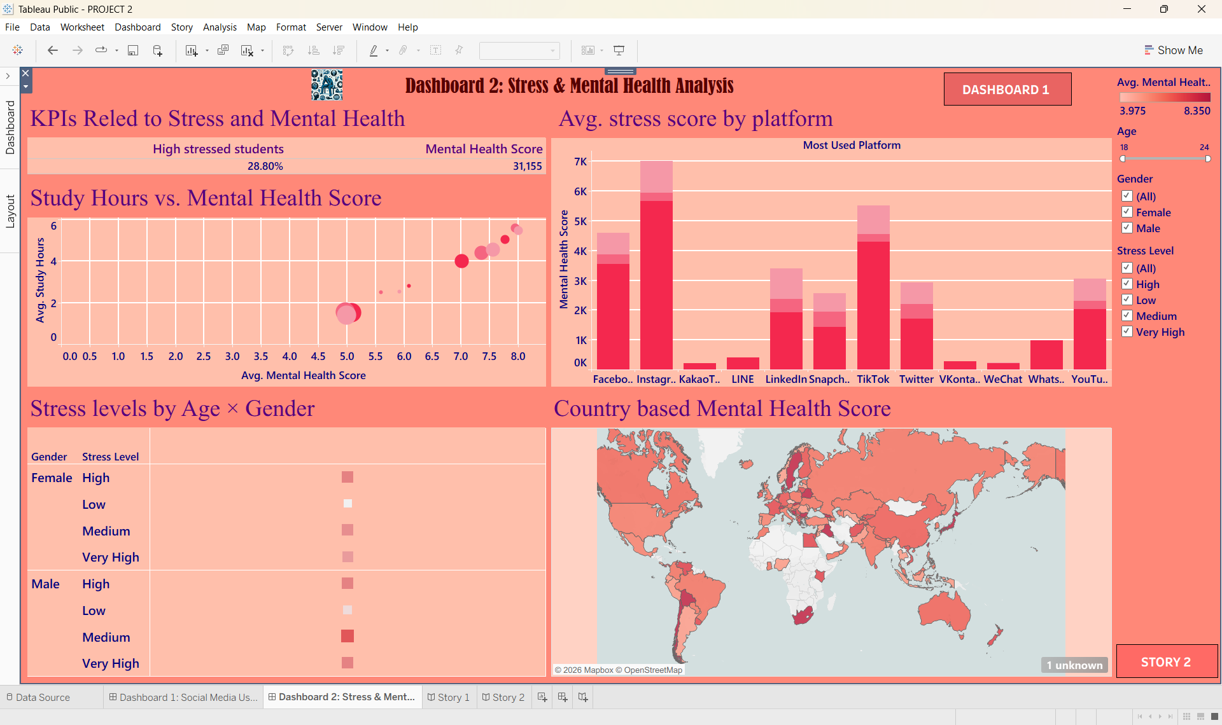

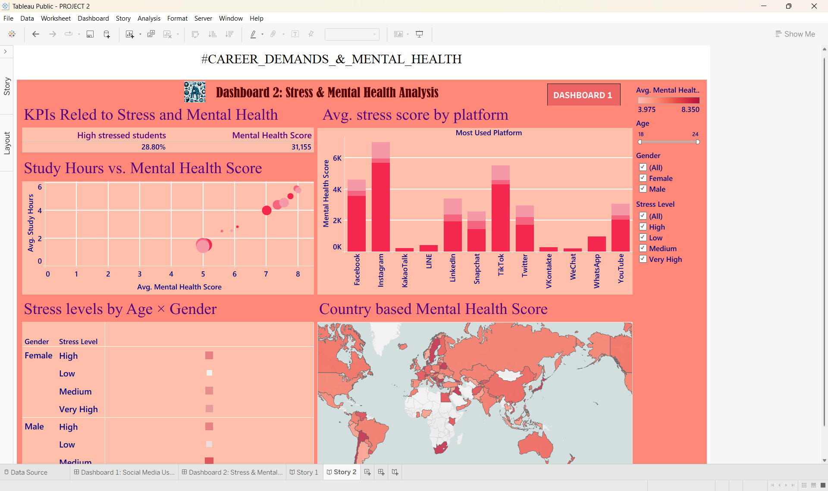
STORY

